006BC2744 - Day 17 (7 August 2026)

Task 1: What is data binding?

Data binding is the process of connecting your application's data (state) with the user interface so that changes in one are reflected in the other.

In React: Data binding is primarily one-way. Data flows from the component's state/props → UI, and user input updates the state using event handlers like onChange, which then re-renders the UI.

const [name, setName] = useState("");
<input
value={name}
onChange={(e) => setName(e.target.value)}
/>
<p>Hello, {name}</p>

Here, the input displays the value from name (state), and typing updates the state through onChange, causing the UI to update automatically.

Task 2: What do you understand by one way data binding and two way data binding?

One-way data binding: Data flows in a single direction, from the application's state/model to the UI. Any user input must be handled explicitly (e.g., through event handlers) to update the state. React primarily uses one-way data binding.

Two-way data binding: Data flows in both directions—changes in the UI automatically update the model, and changes in the model automatically update the UI. Frameworks like Angular support two-way data binding using features like [(ngModel)].

Task 3: When do you use one way data binding and when to use two way data binding?give examples.

One-way data binding is used when data flows in a single direction—typically from the component (state) to the UI, or from the UI to the component through events. In React, displaying user details with {user.name} or handling input with onChange are examples of one-way binding.

Two-way data binding is used when changes in the UI should automatically update the data model and vice versa. React doesn't provide true two-way binding by default, but it can be achieved using controlled components, where an input's value is tied to state and updated via onChange (e.g., a form input that always reflects the latest state).

Task 4: What is the state in react?

State in React is an object (or value) that stores data specific to a component and can change over time. When the state is updated (using useState or setState), React automatically re-renders the component to reflect the new data in the UI.

Task 5: Can you explain SPA?

SPA (Single Page Application) is a web application that loads a single HTML page and dynamically updates the content without reloading the entire page. Frameworks like React, Angular, and Vue use client-side routing to provide a faster, smoother user experience, similar to a desktop application.

Task 6: What is DOM?

DOM (Document Object Model) is a tree-like representation of an HTML document where each element is treated as an object (node). It allows JavaScript to dynamically access, modify, add, or remove HTML elements, styles, and content on a web page.

Task 7: What is virtual DOM?

Virtual DOM is a lightweight, in-memory copy of the real DOM maintained by React. When the state changes, React updates the Virtual DOM, compares it with the previous version (diffing), and applies only the necessary changes to the real DOM, improving performance.

Task 8: What are props in react ? Can you explain about prop drilling?

Props (properties) are read-only values passed from a parent component to a child component to share data or functions. Prop drilling occurs when props are passed through multiple intermediate components just to reach a deeply nested child, making the code harder to maintain.

Task 9: Why do we use react?give importance and describe in detail.

We use React to build fast, interactive, and reusable user interfaces, especially for Single Page Applications (SPAs). Its component-based architecture, Virtual DOM for efficient rendering, and one-way data flow make applications easier to develop, maintain, and scale while delivering better performance and user experience.

Task 10: What do you understand about component based architecture?

Component-based architecture is a design approach where the UI is divided into small, independent, and reusable components. Each component manages its own logic and rendering, making the application easier to develop, test, maintain, and reuse across different parts of the application.

Task 11: Explain the lifecycle of the react component with a diagram.. Describe mounting , unmounting etc ..

The React component lifecycle describes the different stages a component goes through from creation to removal. In functional components, these stages are managed using the useEffect hook.

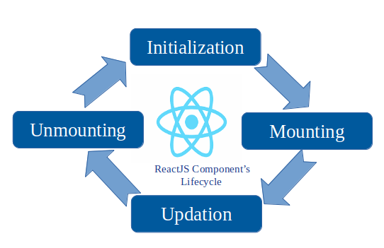
- Mounting: The component is created and inserted into the DOM (e.g., fetching data in useEffect(() => {}, [])).
- Updating: The component re-renders when its state or props change.
- Unmounting: The component is removed from the DOM, and cleanup tasks (like clearing timers or unsubscribing from events) are performed in the cleanup function of useEffect.

Task 12: What are Hooks in react? Why use hooks- importance? What are different types of hooks?

Hooks are special React functions that let functional components use features like state, lifecycle methods, and context without writing class components. They make code simpler, reusable, and easier to manage. Common hooks include useState, useEffect, useContext, useRef, useMemo, useCallback, and useReducer.

Task 13: What is react redux architecture? explain in detail.

React Redux is a state management library used to manage and share application state across multiple components without prop drilling. It follows a unidirectional data flow where Components dispatch Actions, Reducers update the Store, and subscribed components automatically receive the updated state. This architecture makes large applications more predictable, scalable, and easier to debug.

Step 1: Create the root app —> app.jsx – with h1 tag in the function app
And export it..

Step 2: In src..
Create a components folder and add a function component.

Like dashboard.jsx

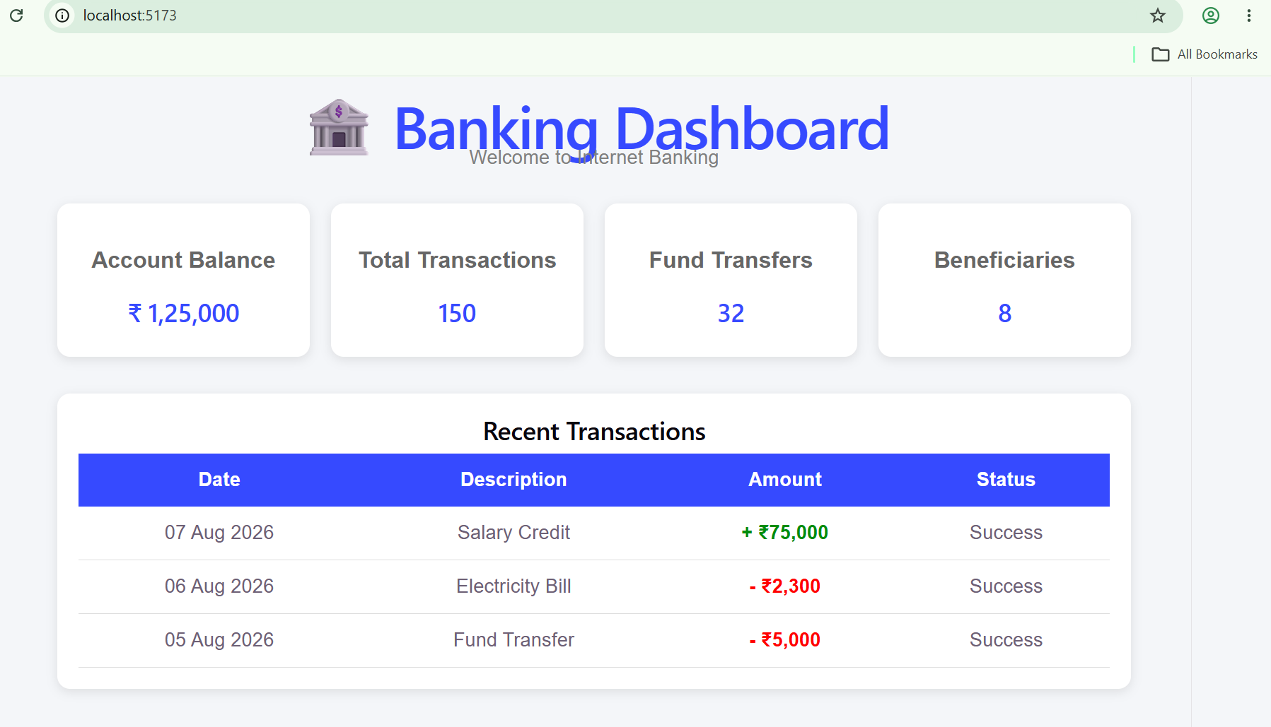

Step 3: In components/ create Accounts.jsx

Step 4:

Create a usestate … initialize and use it to display the current balance

Import useState hook

import React, { useState } from "react";// react hook - usestate

Initialize the useState

const [balance, setBalance] = useState(1000);

// Handle new transaction
const handleTransaction = (type, amount) => {
let newBalance = balance;
if (type === "Deposit") newBalance += amount;
if (type === "Withdraw") newBalance -= amount;
setBalance(newBalance);

Step 4:

Conditional rendering like
Balance <0 —>

{balance < 0 && <p style={{ color: "red" }}>⚠️ Overdraft Alert!</p>}

Step 5: In components / create TransactionForm.jsx

Now

Step 6: Can you implement use state hook in TransactionForm.jsx
For setAmmount
Set Type → deposit.. Or so

